# Module 4Activity 1

# Brandon Trinkle

# IFT 458: Middleware Prog & Database Sec

# Professor: Dinesh Sthapit

# Mar 1, 2025

# Module 4 Activity 1

1. *Terminal showing successful installation of dependencies.*

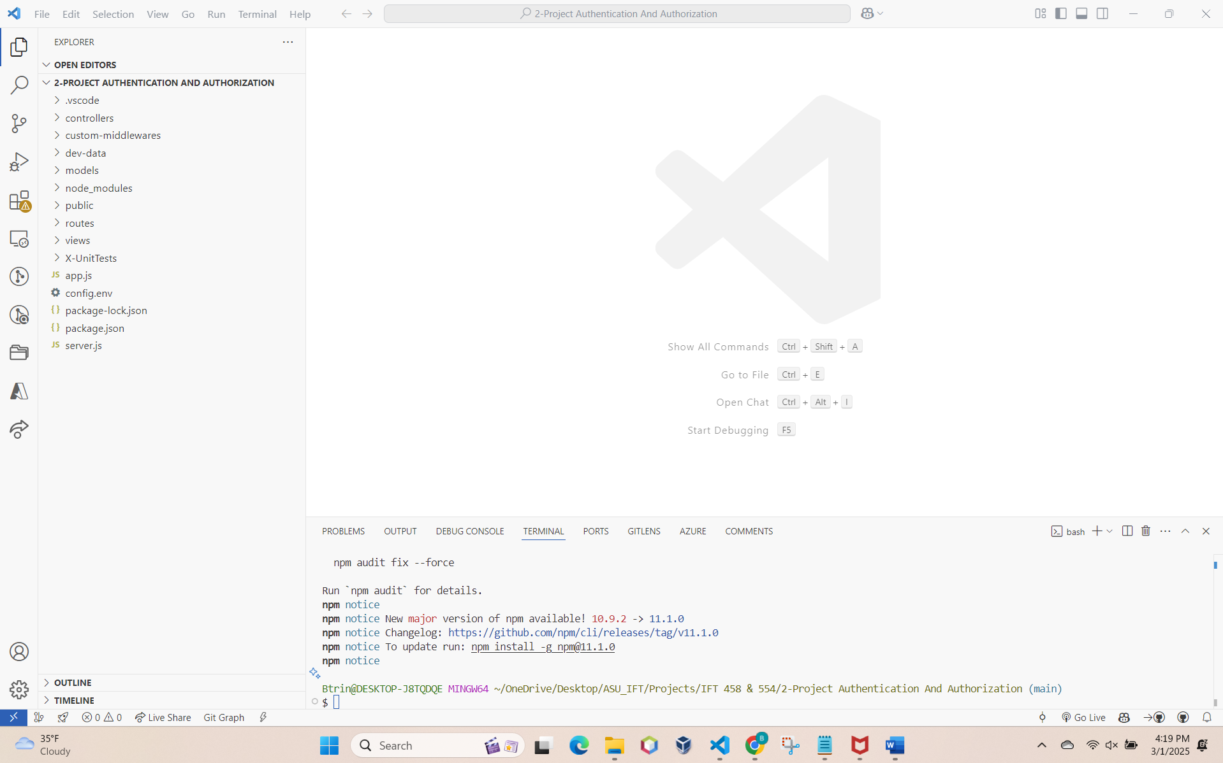

1. *Screenshot of Debug Terminal open in VSCode.*

1. *Screenshot of Breakpoints set in authMiddleware.js.*

1. *Screenshot of "Debugger Attached" message in the terminal.*

*Note: The iftuser password in config.env didn't work. I changed the MongoDB database and password to the one created earlier in class. This wasn't specified in the instructions, but it was necessary to complete the assignment on time.*

1. *Screenshot of Homepage of the application in the browser.*

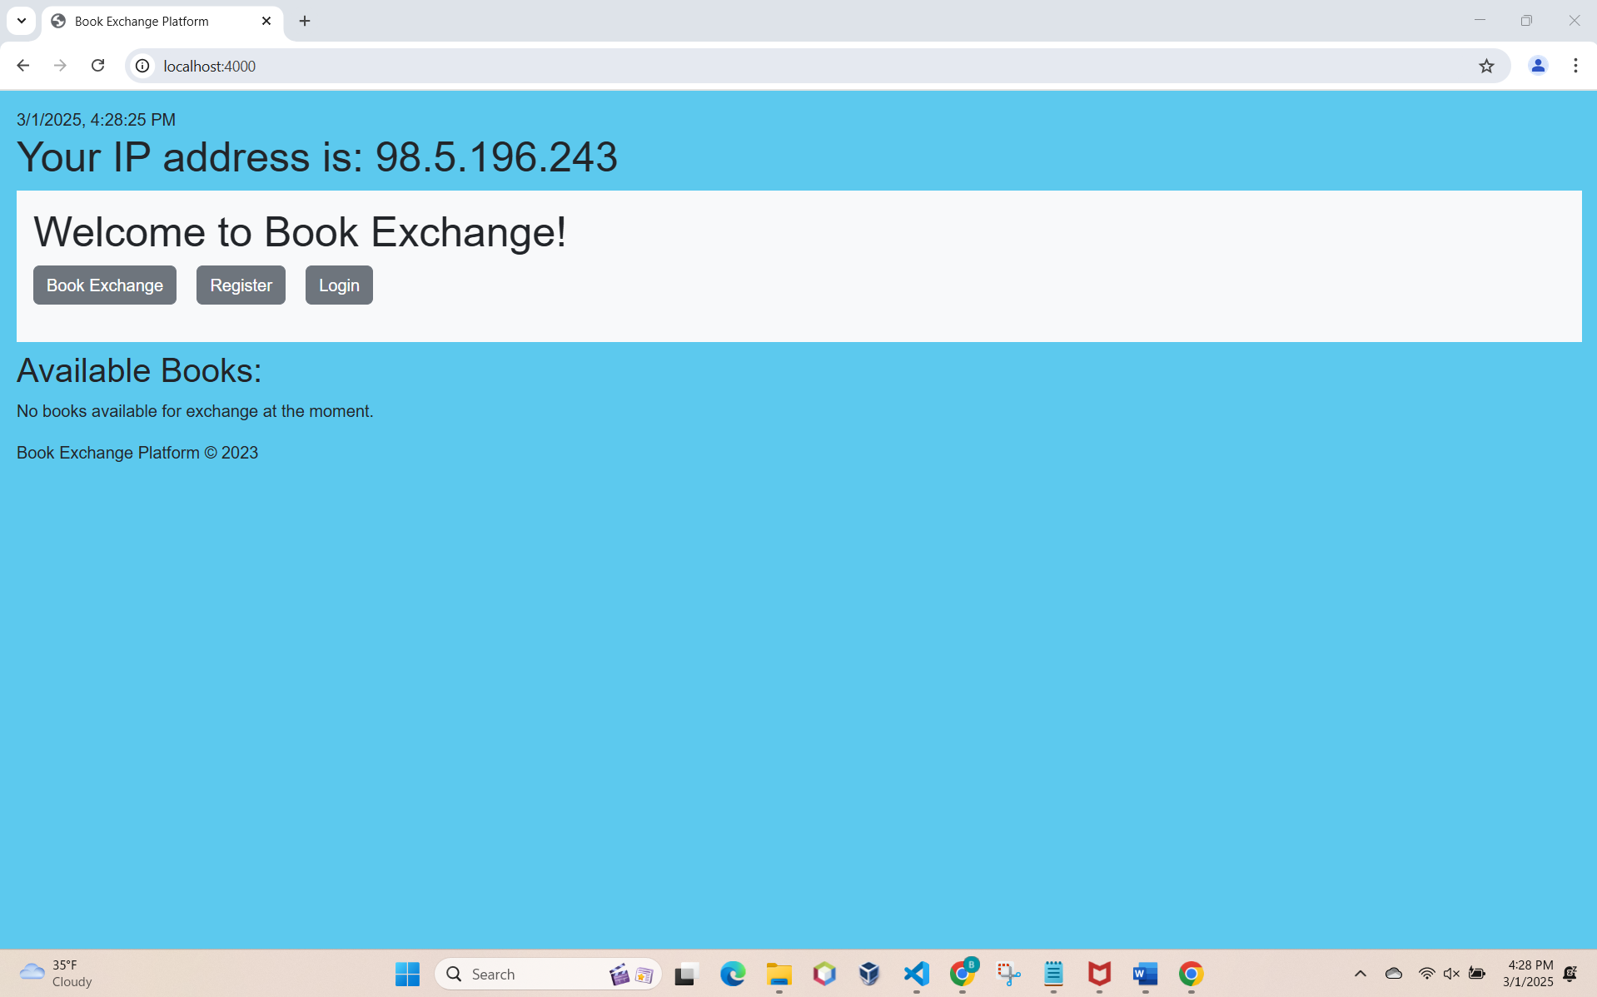

1. *Screenshot of the "Add New Book Exchange" page and the login screen.*

1. *Screenshot of "Add New Book Exchange" page, indicating access to protected resources.*

1. *Screenshot of terminal confirming the application has been stopped and restarted.*

*Note: Was able to stop and restart the server and did not have to log back in. However, this appears like a security vulnerability.*

1. *Screenshot of direct access to the "Add New Book Exchange" UI, showing session persistence.*

1. *Screenshot of JWT token data and payload verification on jwt.io.*

*Note: Jwt token decoder confirms that the hash encoded in our jwt token matches the hash assigned to our _id stored in MongoDB. The specific users collection stores login information – which uses jwt (json web token) as per the code specified in authController.js and userModel.js.*